Web Services Documentation

# Objectives:

* Familiarize with Web Services concepts using .NET technology
* Implement a Client-Server Application.

# Part 1 – Web Service:

* When talking about Client-Server applications, one vital part of the application is the **Web Service side**.
* For this lab, we had to develop the following methods for the web service:
  + Conversion from Fahrenheit to Celsius and vice versa.
  + Display the local Date and time.
  + Conversion between two currencies (i.e. lei -> euro).
  + Display a list of 5 items.
* The implementation of the methods are shown in Fig. 1 and Fig. 2 and the web service displayed in browser is shown in Fig. 3 below:

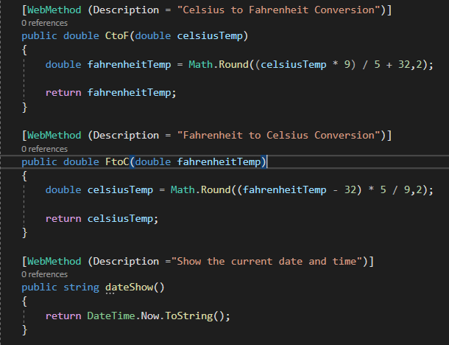

Fig. 1 Temperature Conversion and local date and time methods

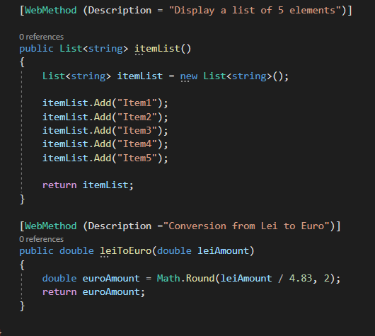

Fig.2 Display a five-item list and conversion methods

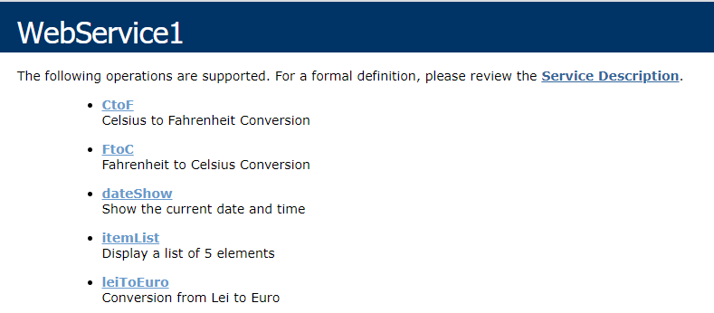

Fig. 3 Web Service Methods in Browser

# Part 2 – Console Client

* The second piece of the client-server application is the **Client Part.**
* The first Client is a **Console Application** which will use the methods define in the web service
* In order to connect the Client with the Server, we need to add the reference to the client, as well as to instantiate the **WebService1SoapClient** class
* The instantiation of this class is shown in Fig. 4 below:



Fig. 4 Link between Client and Server

* The meth5od implementation as well as the output is shown in the figures below:

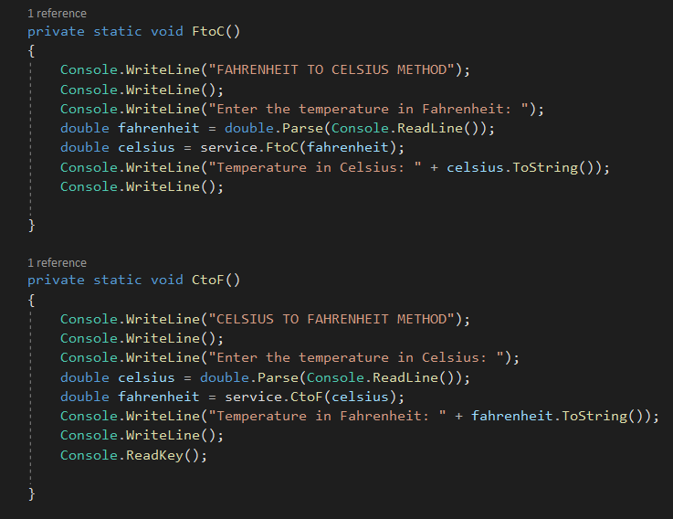

Fig. 5 Temperature Conversion methods implementation

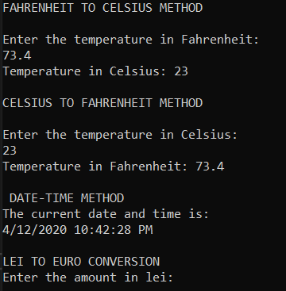

Fig. 6 Output of the methods from Fig. 5

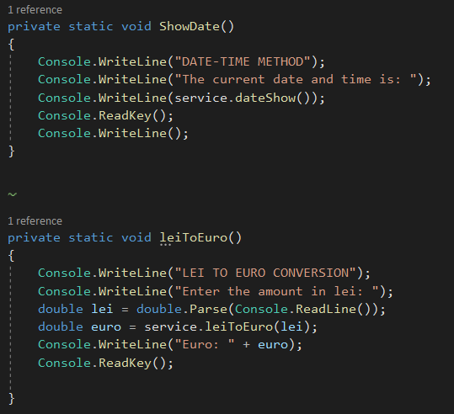

Fig. 7 Method implementation for showing the date and making currency conversion

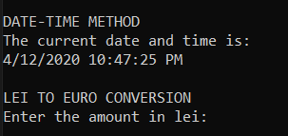

Fig. 8 Output of the methods from Fig. 7

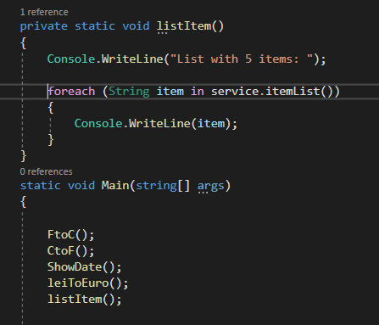

Fig. 9 Implementation of 5-item list and the call of the methods in the main method

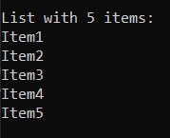

Fig. 10 Output of the method from Fig. 9

# Windows Form Client

* The second clients is a **Windows Form App**
* This client is somehow similar with the previous one; the only difference is that this time we have a UI between the client and the web service.
* The design of the UI, the functionality as well as the code snippets are presented in the following figures below:

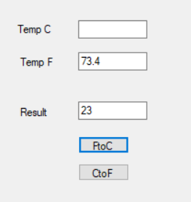 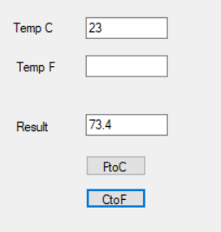

Fig. 9 Fahrenheit to Celsius Conversion Fig. 10 Celsius to Fahrenheit Conversion

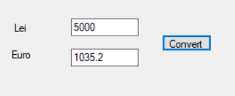

Fig. 11 Currency Conversion

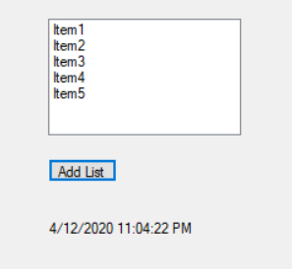

Fig. 12 Listbox Items and Current Date and Time

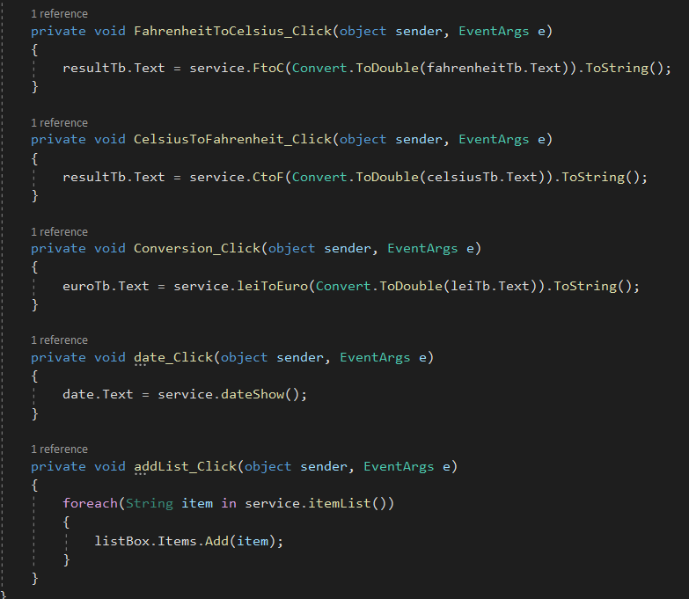

Fig. 13 Source Cone for Windows Form Client